A201 Exercise—Numerical Integration Exercise

AUTHORIZED RESOURCES: your instructor, your course notes, course materials and other cadets (but do not copy any of another cadet’s work)

Background:

Many integration problems are very difficult, if not impossible to solve analytically, so we often turn to numerical methods. These often give us very accurate solutions by letting the computer crunch through many calculations.

Your exercise is to recreate the Simulink model described in this lesson.

Tasks:

Build the following Simulink model.
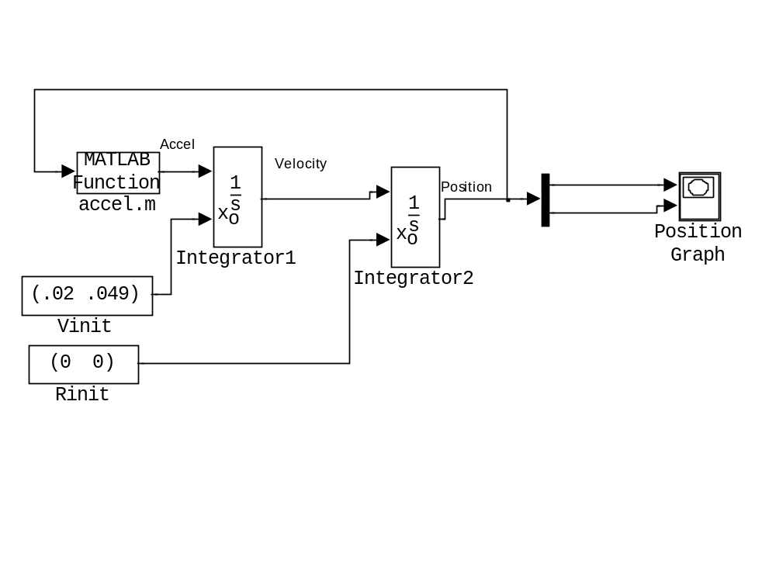
Hint: For the integration double click on the block and change the “Initial Condition Source” to “external.”

Within the gravity model (accel.m), the horizontal acceleration is zero, and the vertical acceleration is:

Accel_{y} = -μ/R²

See the powerpoint slides for more details on this module.
Make the model produce the following plot.

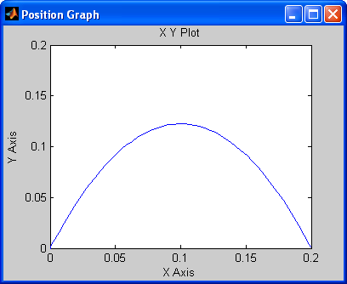

Note: You may fulfill this requirement by having the instructor verify your work by any of the following means:
- Signoff by viewing during class assigned -or-
- Bring hard copies to class for signoff

  - Model (Documented, including accel.m documentation)

  - Resulting Plot (Push the “Alt-PrintScreen” keys to put a copy of the screen on the clipboard, then paste it into Word and then print that.)

